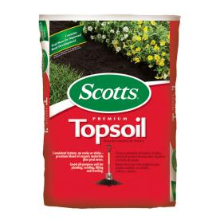
Scotts Topsoil®

- .75 Cubic Foot Coverage
- Premium blend of organic materials
#10

- Peat Moss Added

$2.99
71151750

